Quantitative Strategies on High Frequency Data

Final Report

Team 6: Sevin Tan Erdi (474531), Thuan Tran (476708)

Jan 25, 2026

# Group 1 (S&P 500 Equity Index Futures) | Strategy Description

## Asset Description

The selected asset for Group 1 is the S&P 500 equity index futures contract, which provides exposure to the broad U.S. equity market. These properties make S&P 500 futures particularly well suited for systematic intraday trading strategies, as they reduce market microstructure noise and transaction cost distortions, allowing trend-based signals to be more reliably translated into realized performance.

## Strategy Approach

The final strategy follows a trend-following approach applied to intraday S&P 500 futures data. The core objective is to capture persistent intraday directional movements while avoiding excessive turnover and minimizing the impact of transaction costs.

Unlike mean-reversion strategies that rely on frequent small price corrections, this approach assumes that intraday trends in equity index futures can persist over multiple hours, especially during periods of strong macroeconomic signals, institutional order flow, or directional risk sentiment.

The strategy is explicitly designed not to be continuously invested in the market. Instead, positions are taken only when the strength of the detected trend is sufficiently large relative to prevailing market volatility.

## Strategy Type and Core Elements

The strategy is implemented as an exponential moving average (EMA) crossover model enhanced with volatility-scaled entry and exit thresholds. It consists of the following key components:

1. Trend Direction Indicator A fast and a slow EMA are used to identify the prevailing intraday trend direction.
2. Signal Strength Measure The magnitude of the EMA spread is used as a proxy for trend strength.
3. Volatility Filter and Hysteresis Mechanism Entry and exit decisions are conditioned on recent realized volatility to avoid reacting to noise-driven price fluctuations.

This structure allows the strategy to dynamically adapt to different volatility regimes in the S&P 500 futures market.

## Signal Construction

Let $P_{t}$ denote the S&P 500 futures price at time $t$.

Two exponential moving averages are computed:

* A fast exponential moving average with a window length of 20 bars, denoted as $EMA_{fast}\left(t\right)$
* A slow exponential moving average with a window length of 240 bars, denoted as $EMA_{slow}\left(t\right)$

The raw trend signal is defined as:

$$S_{t}=EMA_{fast}\left(t\right)−EMA_{slow}\left(t\right)$$

The sign of $S_{t}$ determines the directional bias of the strategy:

* $S_{t}>0$: long bias
* $S_{t}<0$: short bias

The absolute value $\left|S_{t}\right|$ represents the strength of the detected trend.

EMA(20) and EMA(240) are chosen to separate short-term price dynamics from the dominant medium-to-long-term trend. EMA(20) reacts quickly to recent price changes, while EMA(240) provides a stable benchmark that filters out short-term noise.

The 20/240 ratio (1:12) ensures sufficient temporal separation between the fast and slow signals, reducing false crossovers and aligning the strategy with medium-term trend-following behavior rather than short-term momentum

## Volatility Scaling and Entry/Exit Technique

To distinguish meaningful trends from random price fluctuations, the strategy employs volatility-adjusted thresholds.

Let $σ_{t}$ denote the realized intraday volatility of the S&P 500 futures, estimated using a rolling window of 120 bars.

Two volatility-scaled thresholds are defined:

**Entry threshold:**

$$\left|S_{t}\right|>k_{\text{enter}}⋅σ_{t}$$

**Exit threshold:**

$$\left|S_{t}\right|<k_{\text{exit}}⋅σ_{t}$$

A position is opened only when the signal strength exceeds the entry threshold. Once a position is opened, it is closed only when the signal falls below the exit threshold. This asymmetric design introduces hysteresis, which prevents frequent position flipping during sideways or noisy market conditions and significantly reduces unnecessary trades.

The volatility-scaled thresholds (k = 5 for exit, k = 10 for entry) are selected asymmetrically to enforce hysteresis: a higher entry threshold avoids overtrading in noisy regimes, while a lower exit threshold allows positions to persist during temporary pullbacks within a trend.

The EMA window pair balances responsiveness to intraday price movements with sufficient smoothing to identify persistent trends. The volatility window provides a stable estimate of recent market conditions without reacting excessively to short-lived volatility spikes.

## Parameter Values

The final parameter values used in the strategy are:

* Fast EMA window: 20 bars
* Slow EMA window: 240 bars
* Volatility estimation window: 120 bars
* Entry multiplier: $k_{enter}=10$
* Exit multiplier: $k_{exit}=5$
* Transaction cost: 12 USD per trade (given)
* Point value: 50 USD per index point (given)

## Strategy Performance Overview (In-Sample vs Out-of-Sample)

The performance of the S&P 500 equity index futures trend-following strategy exhibits a clear distinction between in-sample and out-of-sample periods, highlighting the importance of regime dependency and robustness considerations.

The out-of-sample evaluation consists of five quarters: 2023 Q2, 2024 Q1, 2024 Q3, 2025 Q3, and 2025 Q4. These periods were not used during strategy design or parameter selection and were evaluated using a fixed parameter set.

During the in-sample period, the strategy delivers strong risk-adjusted performance, characterized by consistently positive gross and net Sharpe ratios, as well as a steadily increasing cumulative P&L. Trend persistence during this period allows the EMA(20)–EMA(240) signal to capture directional moves efficiently, while volatility-scaled entry and exit thresholds help filter out minor price fluctuations and reduce unnecessary trades.

While the strategy demonstrates strong in-sample performance, the inclusion of out-of-sample data leads to a pronounced deterioration in aggregate performance metrics. In particular, the overall summary statistic declines from approximately 1.95 in the in-sample period to -1.27 once all out-of-sample quarters are incorporated.

This performance degradation suggests that the trend-following signal, calibrated on in-sample data, is less effective under out-of-sample market conditions. Several out-of-sample quarters are characterized by weaker trend persistence, higher noise, and more frequent regime shifts, resulting in an increased number of false entries and elevated drawdowns after transaction costs.

## Cumulative Gross and Net P&L Analysis

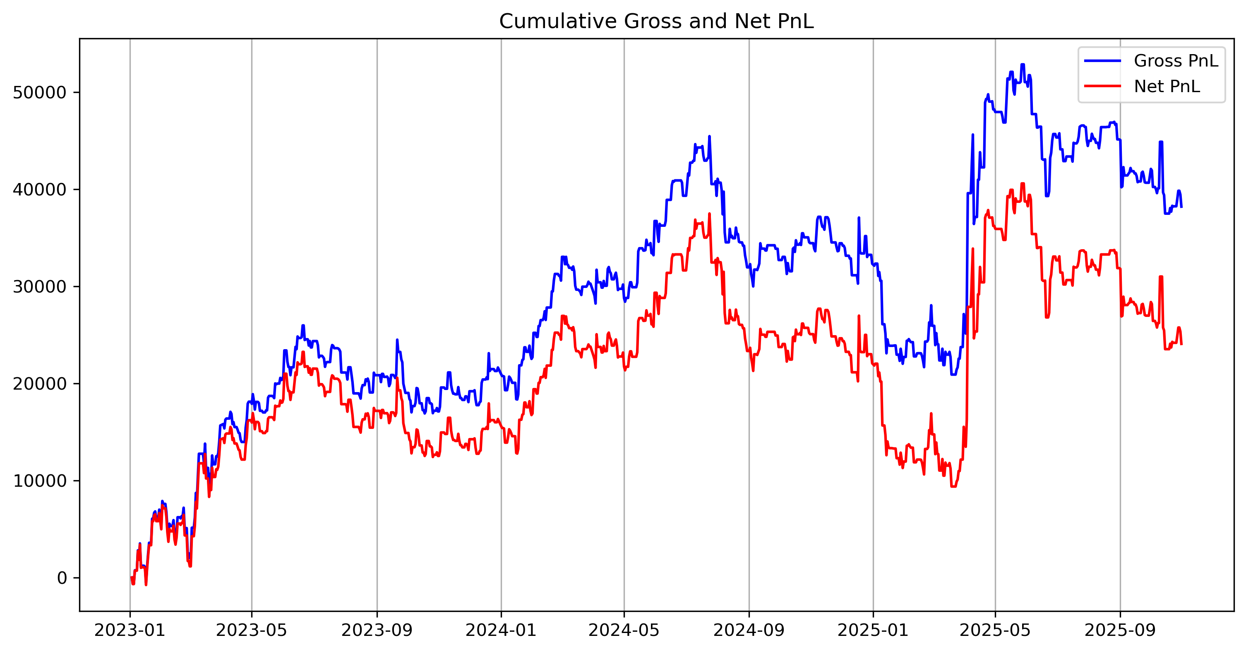

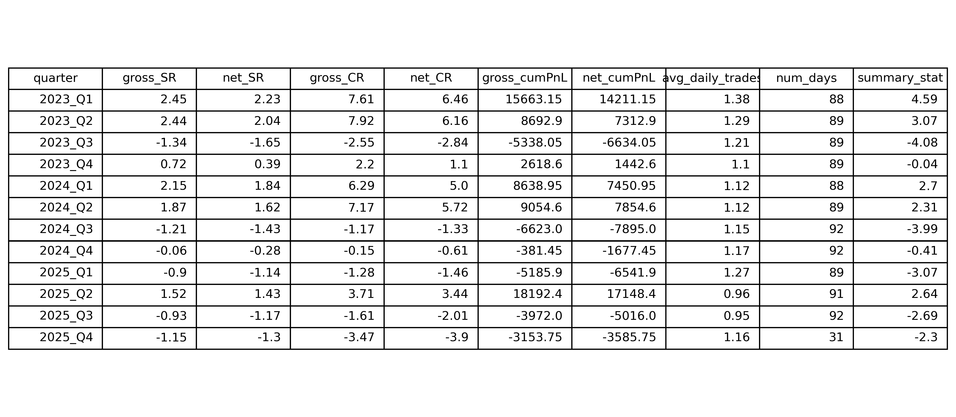

Several key observations emerge:

* The gap between gross and net P&L widens during periods of increased trading activity, underscoring the non-negligible impact of transaction costs.
* Net P&L drawdowns are particularly pronounced during sideways or choppy market regimes, where the trend signal frequently oscillates around the entry and exit thresholds.
* Although the strategy is capable of generating strong gains during sustained directional moves, these gains are often partially offset by losses incurred during subsequent regime shifts.

The cumulative P&L profile suggests that while the strategy is effective in capturing medium-term trends, it remains vulnerable to prolonged non-trending environments.

## Sharpe and Calmar Ratios

Sharpe Ratio

* Sharpe ratios are strongly regime-dependent, ranging from above 2.4 in trending quarters (e.g. 2023 Q1–Q2) to below −1.0 in adverse regimes (e.g. 2023 Q3, 2025 Q3–Q4).
* The consistent gap between gross SR and net SR (≈0.2–0.4 points) confirms that transaction costs materially reduce, but do not fully eliminate, risk-adjusted performance in profitable regimes.

Calmar Ratio

* Calmar ratios exhibit larger dispersion than Sharpe, reaching above 7 in strong trend environments while deteriorating to below −3 in drawdown-heavy quarters, highlighting sensitivity to peak-to-trough losses.
* Quarters with modest Sharpe ratios but negative Calmar values indicate that drawdowns, rather than volatility, dominate downside risk during regime transitions.

Taken together, the Sharpe and Calmar dynamics indicate that drawdown control, rather than volatility reduction alone, is the primary limitation of the strategy in adverse regimes.

## Quarterly Performance Decomposition

To better understand the temporal structure of returns, strategy performance is analyzed at a quarterly frequency.

### Profitable Trend Regimes

Quarters such as 2023 Q1, 2023 Q2-Q4, 2024 Q1-Q2, and 2025 Q2 display strong positive cumulative P&L and high Sharpe ratios. In these periods, price dynamics are characterized by relatively smooth and persistent trends, allowing the EMA-based signal to remain aligned with the dominant market direction for extended periods.

In these quarters:

* Positions are held for longer durations,
* Average daily trade counts remain moderate,
* Transaction cost drag is limited relative to gross returns.

This behavior is consistent with the intended design of the strategy.

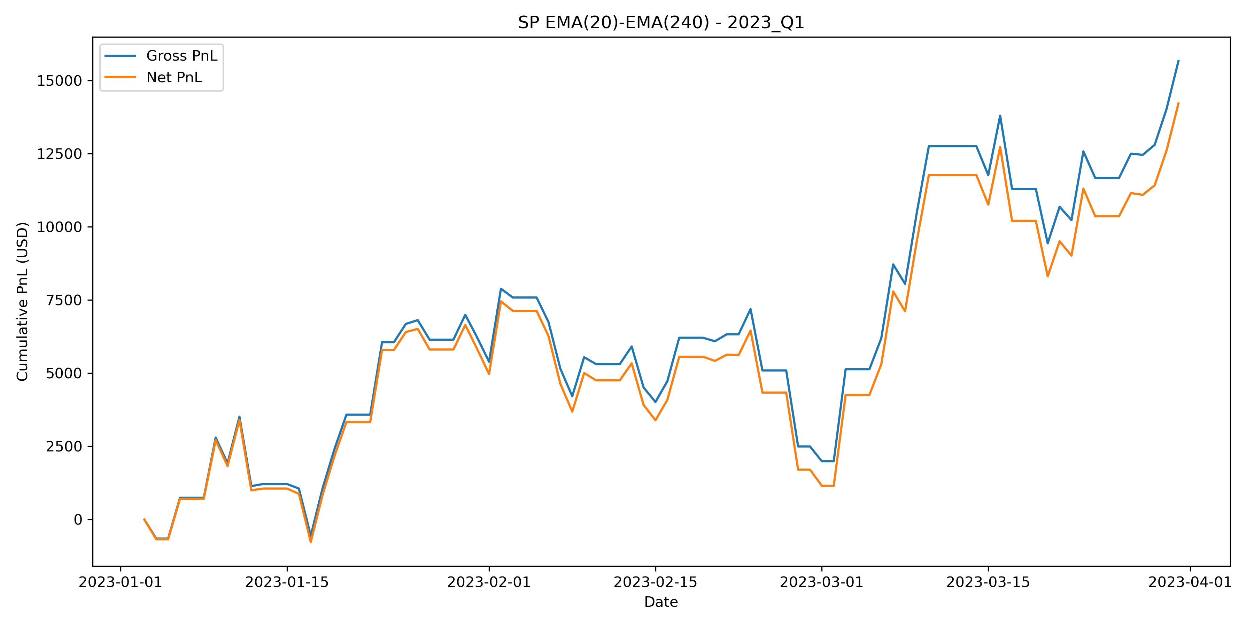 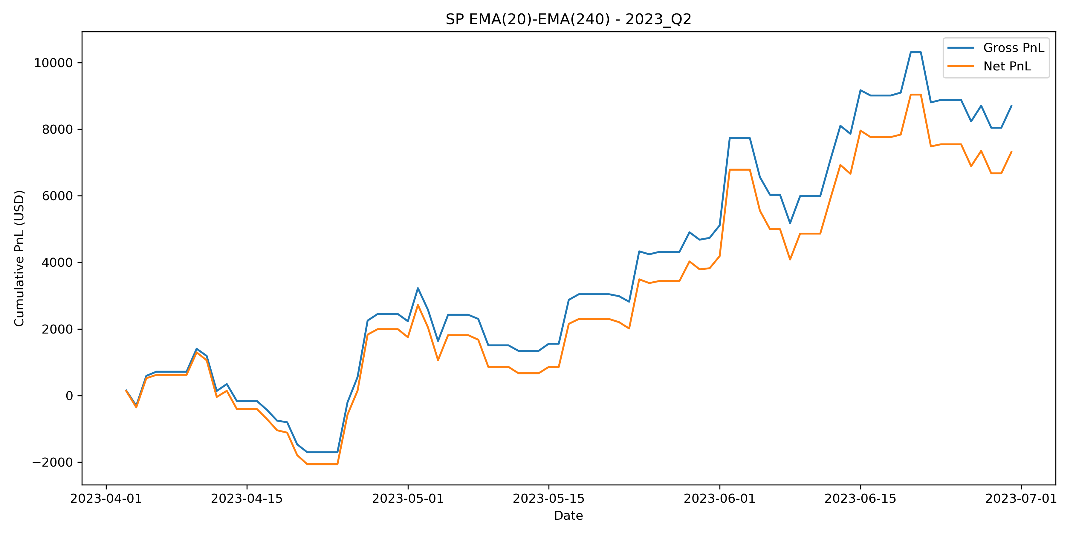

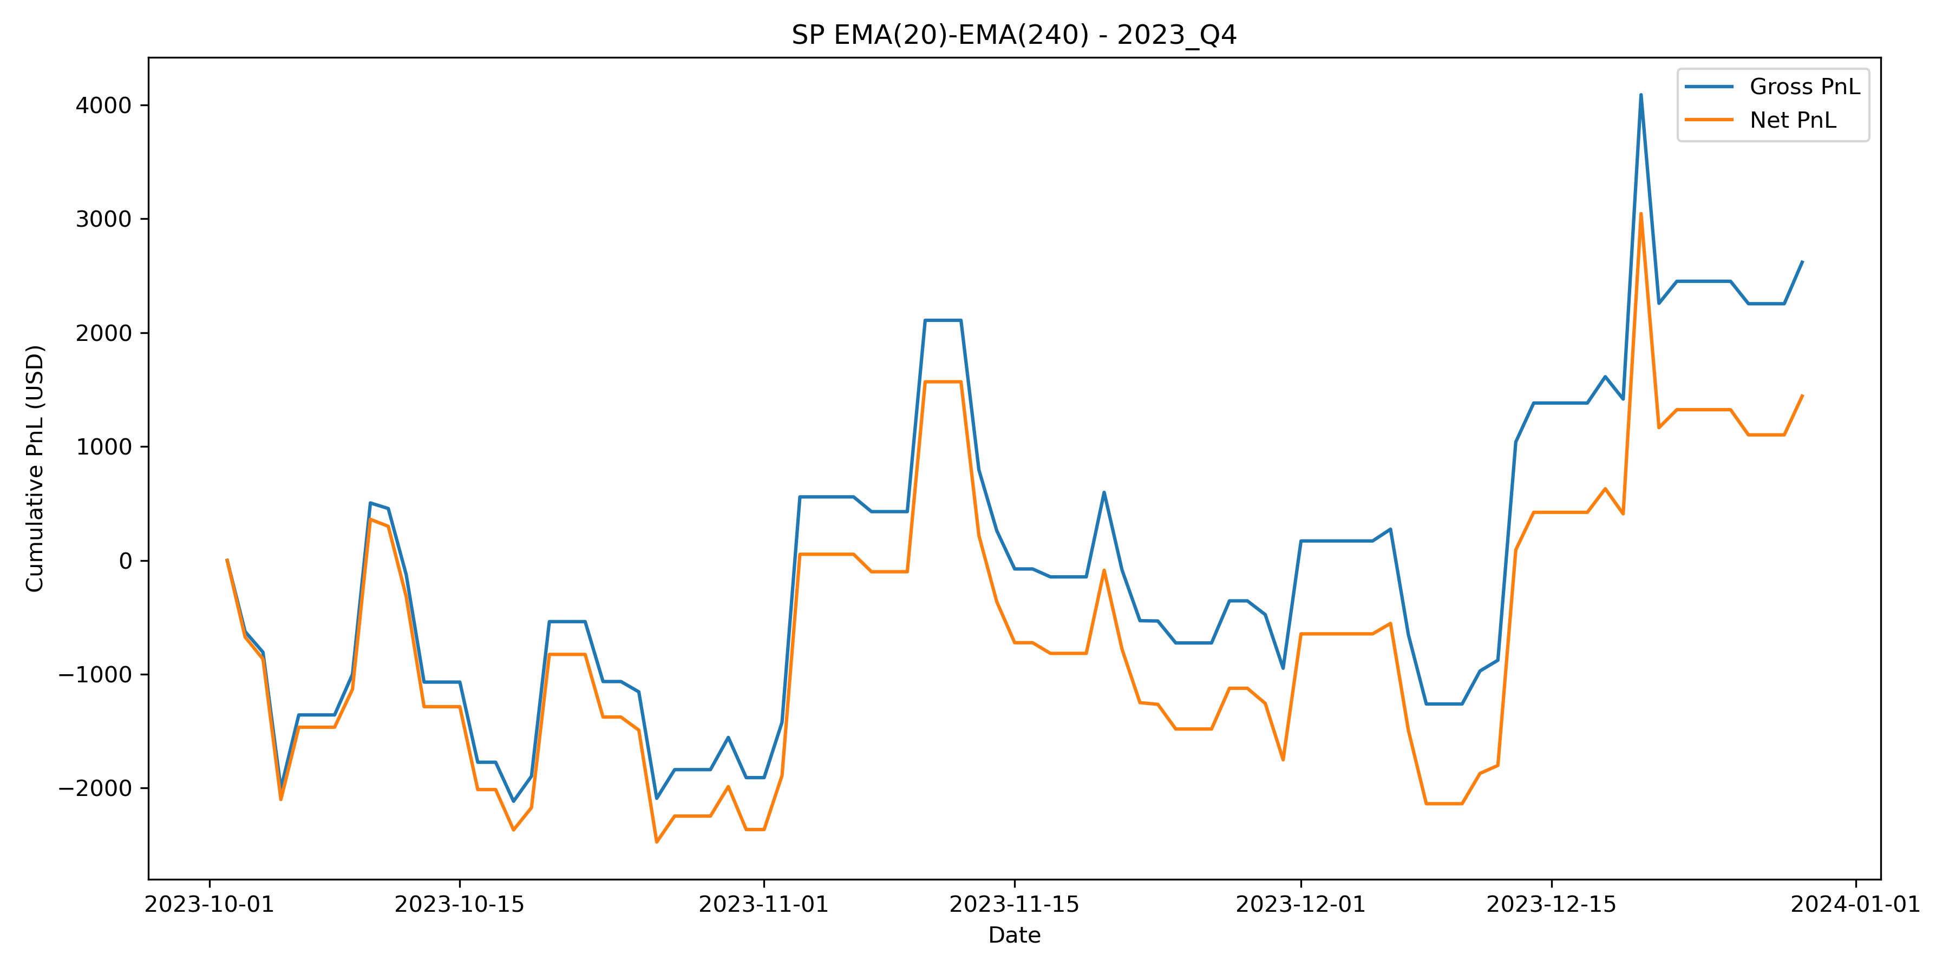 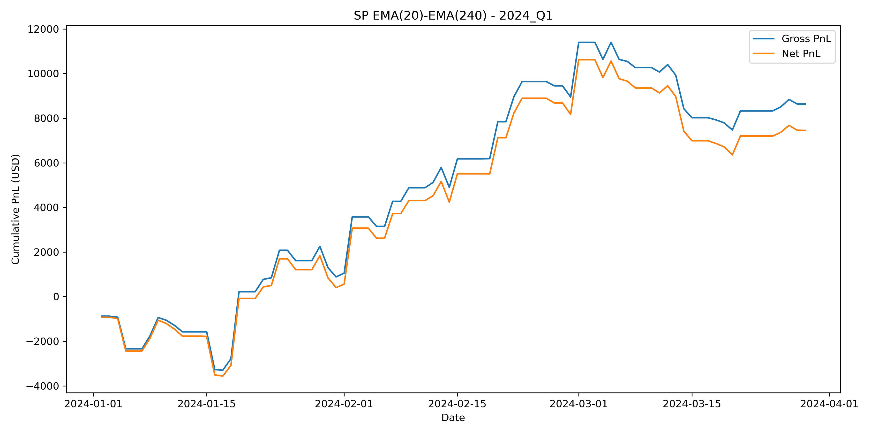

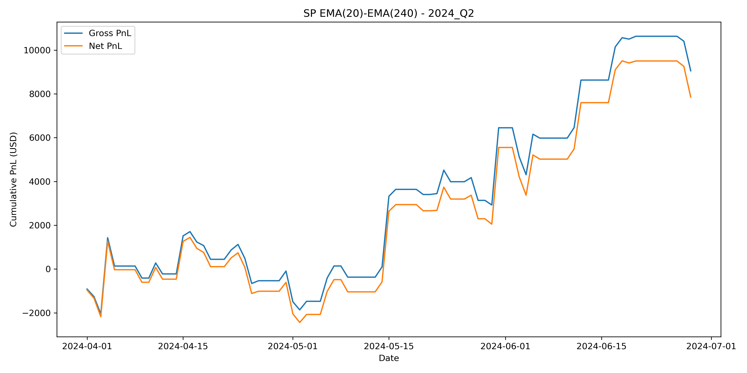 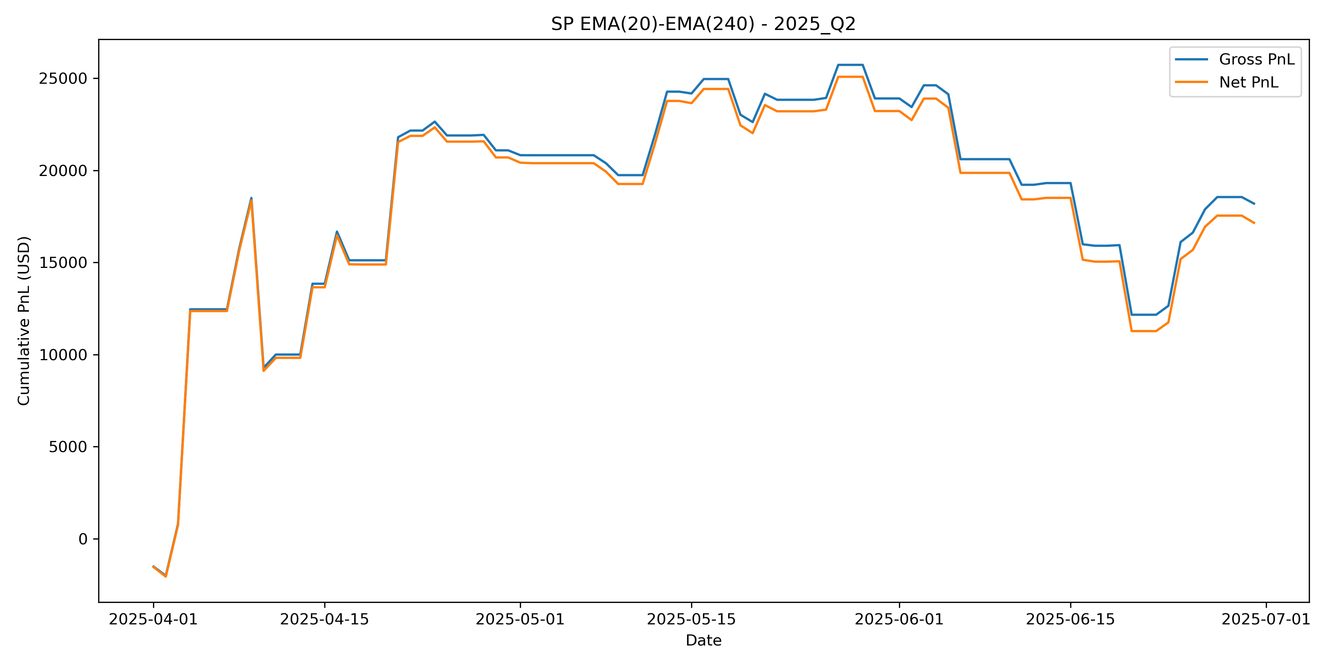

### Adverse and Noisy Regimes

In contrast, quarters such as 2023 Q3, 2024 Q3–Q4, 2025 Q1, and 2025 Q3-Q4 exhibit negative performance, with sharp drawdowns in both gross and net P&L.

The quarterly equity curves reveal:

* Frequent position reversals,
* Rapid erosion of accumulated gains,
* Amplified net losses due to repeated transaction costs.

Notably, the sharp drawdown observed in 2025 Q1 marks the beginning of sustained underperformance in the out-of-sample period. This quarter coincides with increased volatility clustering and reduced trend persistence, conditions under which EMA crossover strategies are known to struggle.

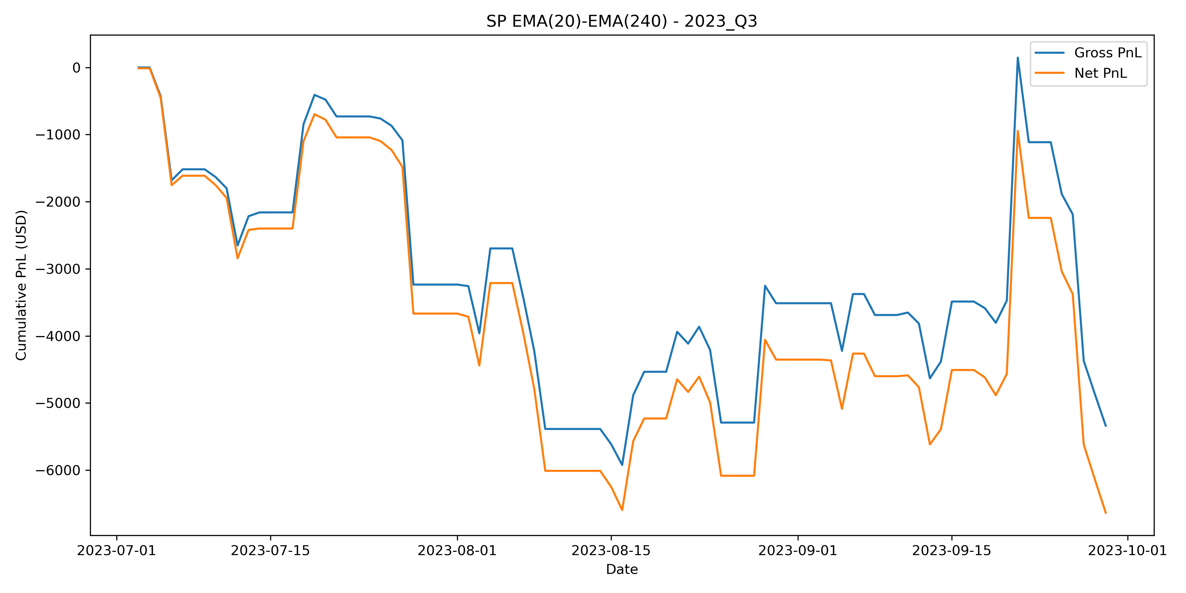 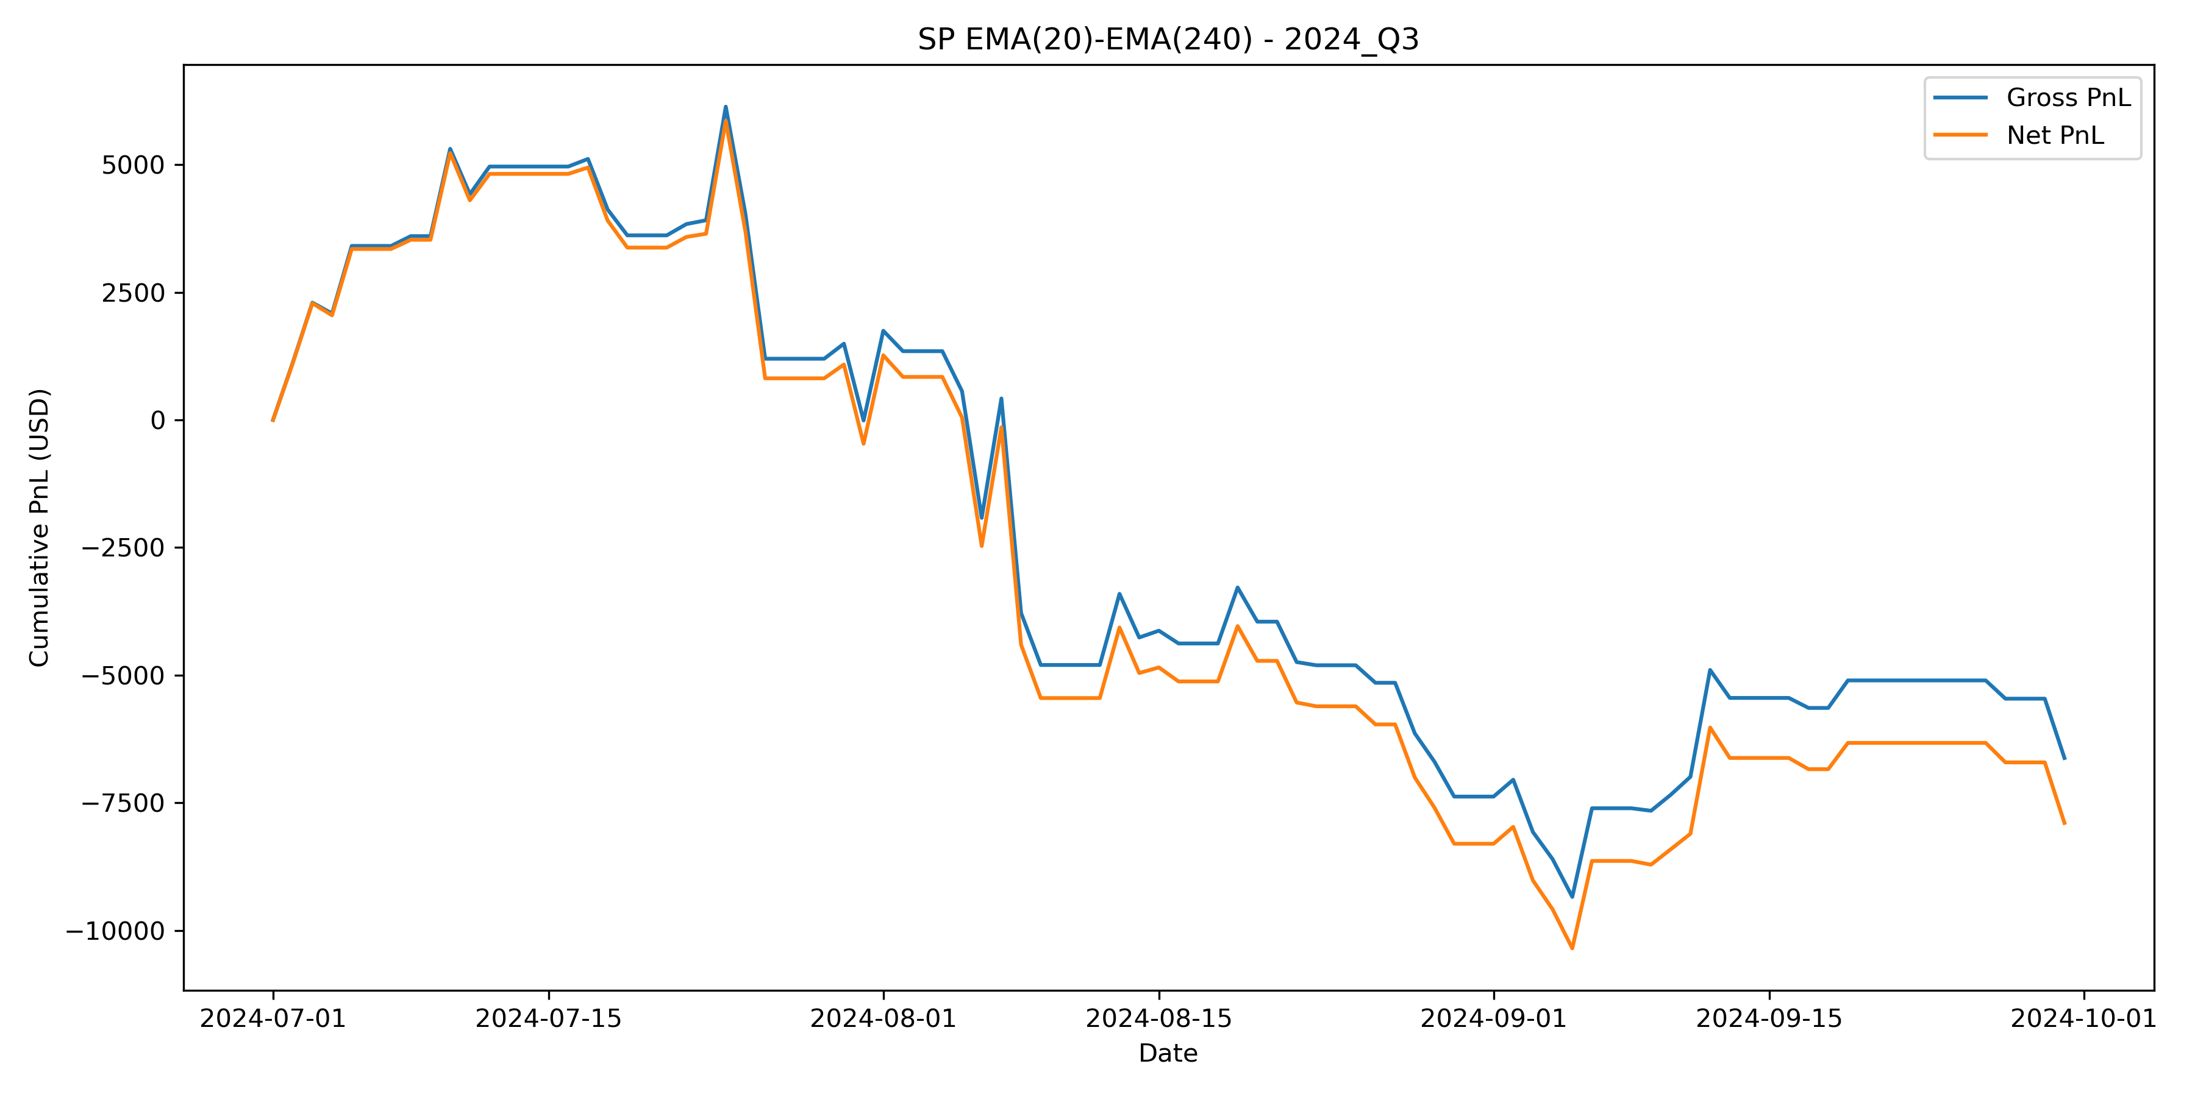

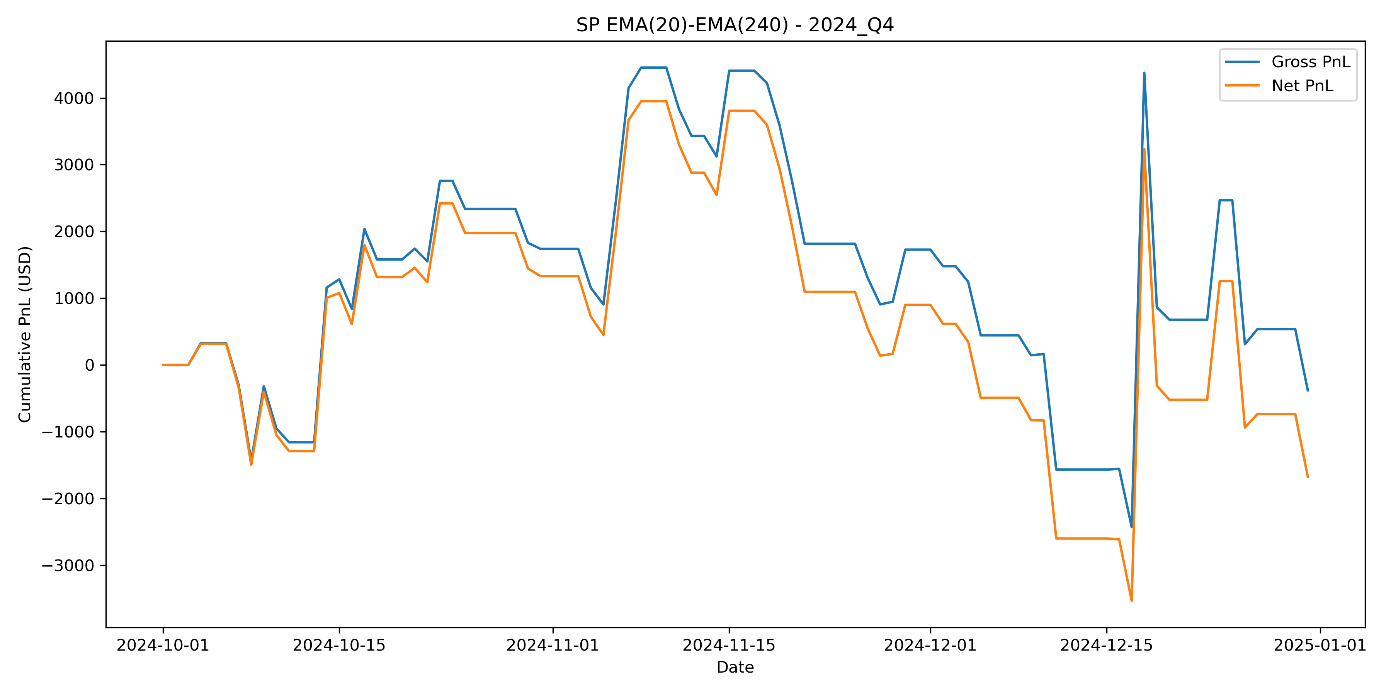 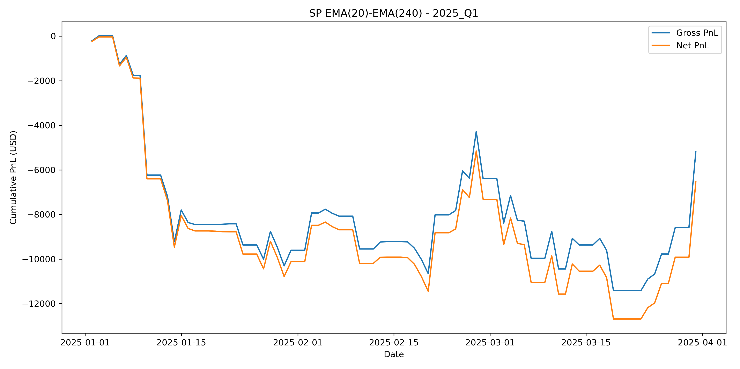

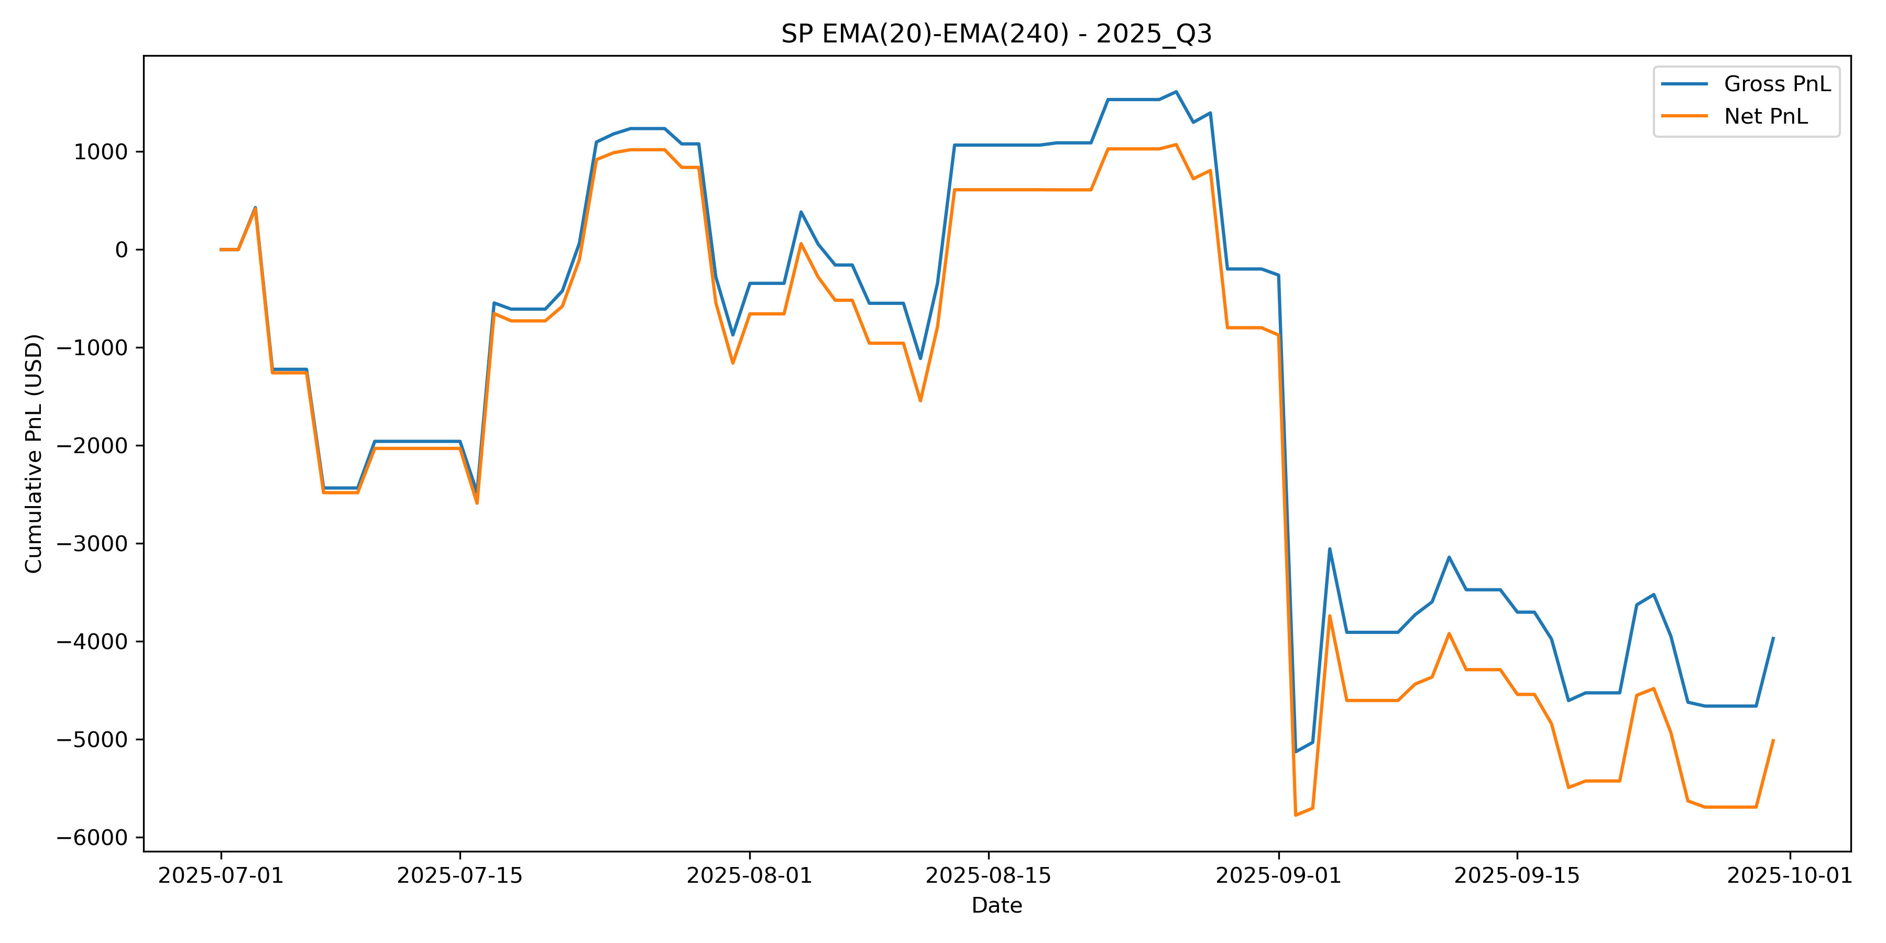 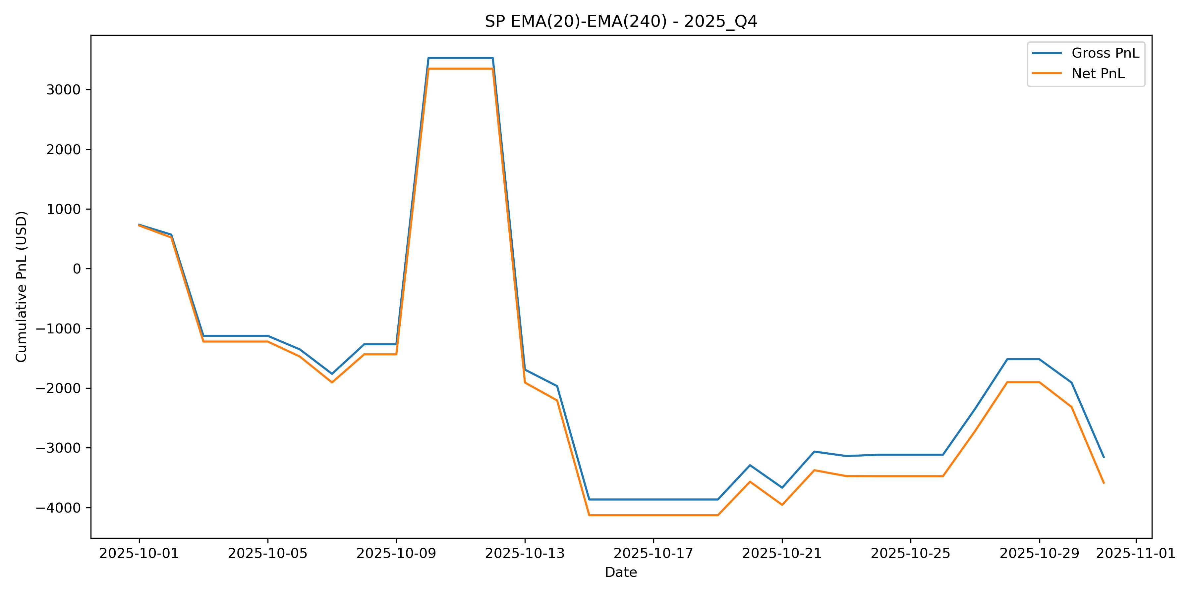

# Group 2 (XAU Futures) | Strategy Description and Out-of-Sample Evaluation

## Asset Description

The selected asset for Group 2 is the XAU (gold) futures contract. Gold futures are highly liquid and actively traded across global trading sessions, making them suitable for systematic intraday trading strategies.

Due to the presence of a daily trading break, Group 2 assets require explicit handling of non-trading periods, which is incorporated into the strategy design and evaluation.

## Strategy Approach

The final strategy follows a momentum-based trend-following approach applied to intraday XAU futures data. The objective is to capture short-term directional price movements while maintaining a simple and transparent rule-based structure.

The strategy is designed to be active only when a clear price trend is detected and to remain flat during non-trading periods and market breaks. All strategy rules and parameters are fixed after in-sample selection and applied unchanged to out-of-sample data.

## Strategy Type and Core Elements

The strategy is implemented as a simple exponential moving average (EMA) crossover model. Its main components are:

1. **Trend Indicator**  
   Two EMAs are used to identify the prevailing intraday trend direction.
2. **Directional Signal**  
   The relative position of the fast and slow EMA determines whether the strategy takes a long or short position.
3. **Trading Restrictions**  
   Positions are closed before the daily trading break, and no trades are opened immediately after the break.

This design ensures that trading decisions are systematic, transparent, and consistent across all quarters.

## Signal Construction

Let $P_{t}$ denote the gold futures price at time $t$.

Two exponential moving averages are computed:

* A fast exponential moving average with a window length of 20 bars, denoted as $EMA_{fast}\left(t\right)$
* A slow exponential moving average with a window length of 100 bars, denoted as $EMA_{slow}\left(t\right)$

The trading signal is defined as:

$$S_{t}=\left\{\begin{matrix}1 & \text{if }EMA_{fast}\left(t−1\right)>EMA_{slow}\left(t−1\right) \\ −1 & \text{otherwise}\end{matrix}\right.$$

Positions are shifted by one bar to avoid look-ahead bias.

The EMA(20,100) configuration balances responsiveness and stability. The fast EMA reacts rapidly to recent price changes, while the slow EMA provides a medium-term benchmark that filters out short-term noise.

## Trading Constraints and Parameters

The following parameters and constraints are applied consistently in all quarters:

* Asset traded: XAU futures
* Data frequency: 5-minute intraday data
* PnL aggregation: intraday trades aggregated to daily PnL
* Fast EMA window: 20 bars
* Slow EMA window: 100 bars
* Point value: 100 USD per point
* Transaction cost: 15 USD per trade

For Group 2 assets, trading is restricted as follows:

* All positions are closed 10 minutes before the daily break (at 16:50).
* No new trades are opened during the first 10 minutes after the break (until 18:10).

## Strategy Performance Overview (In-Sample vs Out-of-Sample)

The strategy is selected based on in-sample performance and evaluated on out-of-sample data without any modification to rules or parameters.

During the in-sample period, the strategy achieves positive cumulative PnL in several quarters, supporting its selection. However, performance is uneven across time, indicating sensitivity to market conditions.

When applied to out-of-sample data, performance deteriorates. Aggregated cumulative PnL becomes flatter and more volatile, and transaction costs significantly reduce net profitability. Several out-of-sample quarters exhibit negative risk-adjusted performance.

## Aggregated Cumulative Gross and Net P&L

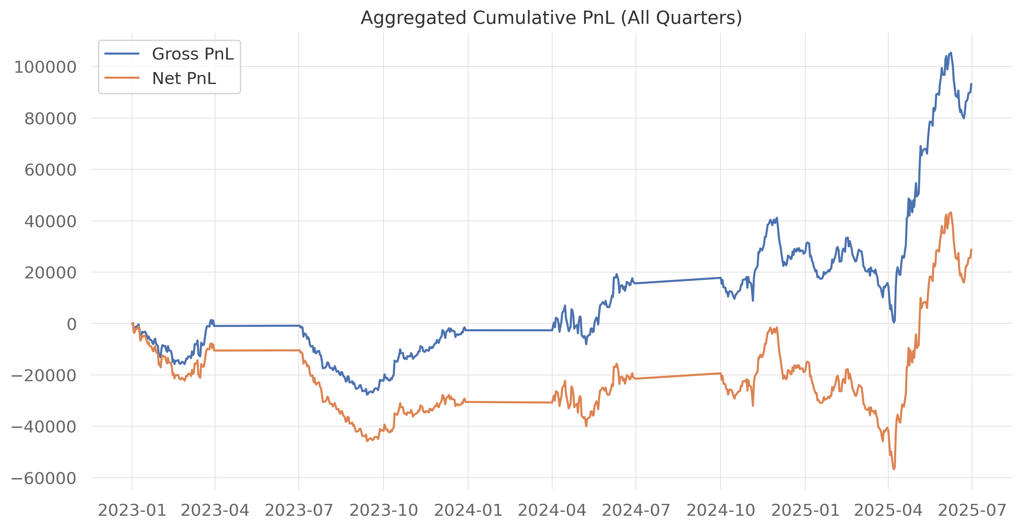

*Figure 1: Aggregated cumulative gross and net PnL in the in-sample period.*

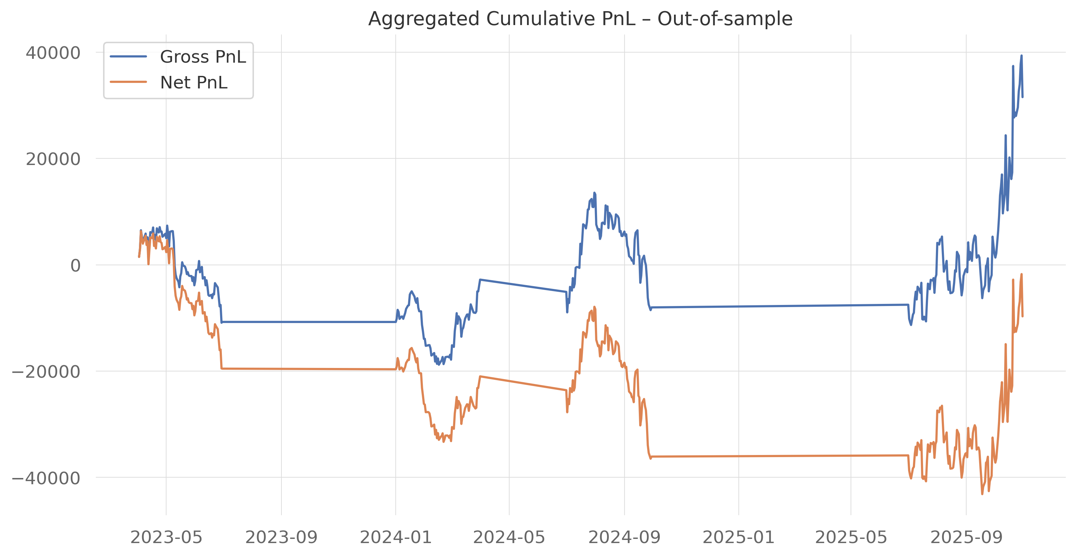

*Figure 2: Aggregated cumulative gross and net PnL in the out-of-sample period.*

Several key observations emerge from the cumulative P&L analysis:

* Gross P&L increases substantially during strong directional regimes, confirming the effectiveness of the EMA(20,100) trend-following signal.
* The gap between gross and net P&L widens during periods of elevated trading activity, highlighting the material impact of transaction costs.
* Net P&L experiences prolonged drawdowns during sideways or noisy market conditions, particularly in the out-of-sample period.

Overall, while the strategy captures trends effectively, its net profitability is significantly reduced once realistic trading frictions are incorporated.

## Sharpe and Calmar Ratios

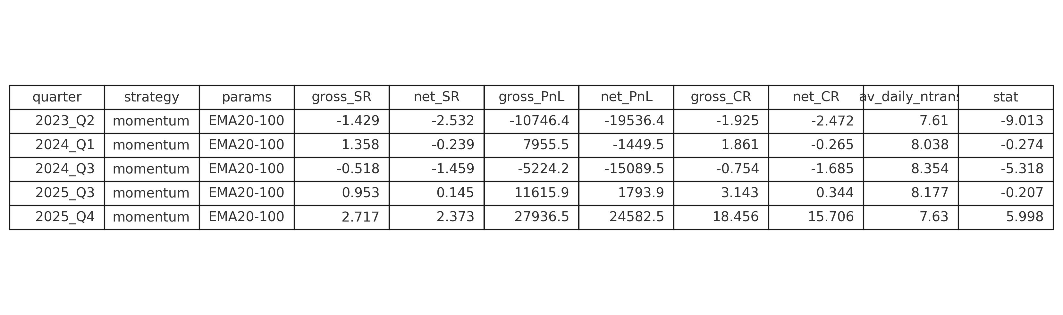

*Table 1: Summary performance statistics for the Group 2 strategy in the out-of-sample period.*

The table reports the required performance measures, including gross and net Sharpe ratios, cumulative PnL, and the average daily number of trades.

### Sharpe Ratio

* Sharpe ratios vary substantially across quarters in the out-of-sample period.
* Strong positive net Sharpe ratios are observed in 2025 Q4, indicating effective performance during favorable trend conditions.
* Negative net Sharpe ratios are observed in 2023 Q2, 2024 Q1, and 2024 Q3, reflecting weak or unstable performance in adverse market regimes.
* The persistent gap between gross and net Sharpe ratios confirms that transaction costs materially reduce risk-adjusted performance.

#### Calmar Ratio

* Calmar ratios exhibit large dispersion across quarters.
* Very high positive net Calmar values are observed in 2025 Q4, indicating strong performance with limited drawdowns.
* Negative Calmar ratios in 2023 Q2, 2024 Q1, and 2024 Q3 highlight the importance of drawdown risk during unfavorable market conditions.

Taken together, these metrics indicate that drawdown control is a key limitation of the strategy outside favorable trend regimes.

## Quarterly Performance Decomposition

### Profitable Trend Regimes

Quarters such as 2023 Q4, 2024 Q2, 2025 Q2 and 2025 Q4 exhibit strong cumulative net P&L, positive Sharpe ratios, and favorable Calmar ratios. In these periods, gold prices display relatively smooth and persistent directional movements, allowing the EMA(20,100) crossover signal to remain aligned with the dominant trend.

During these regimes:

* Positions are held for longer durations,
* Average daily trading frequency remains moderate,
* Transaction cost drag is limited relative to gross returns.

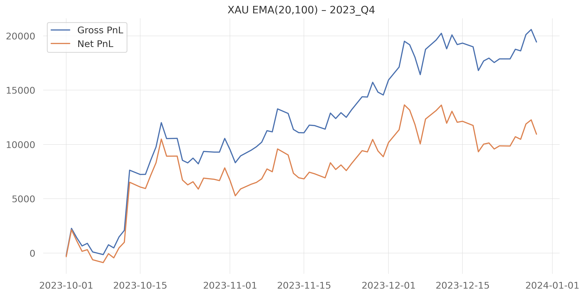 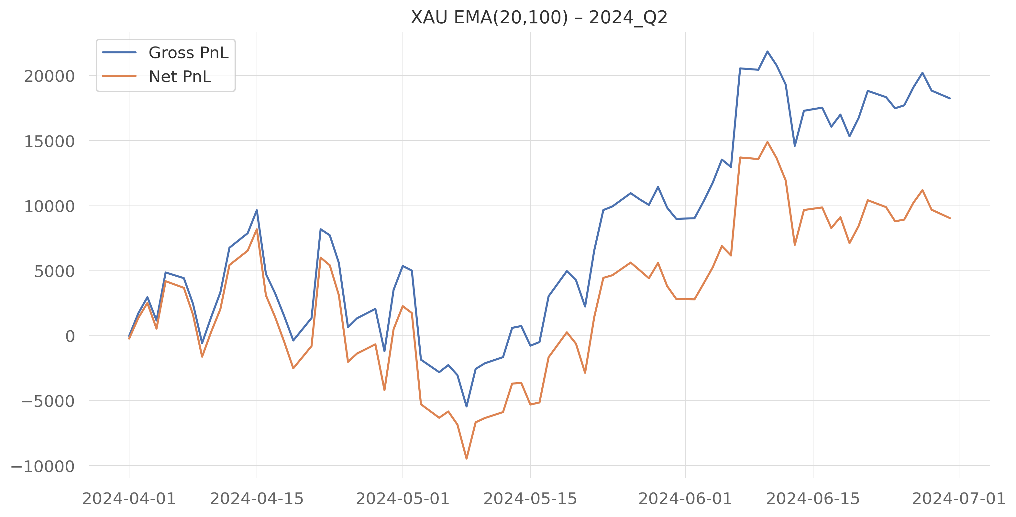

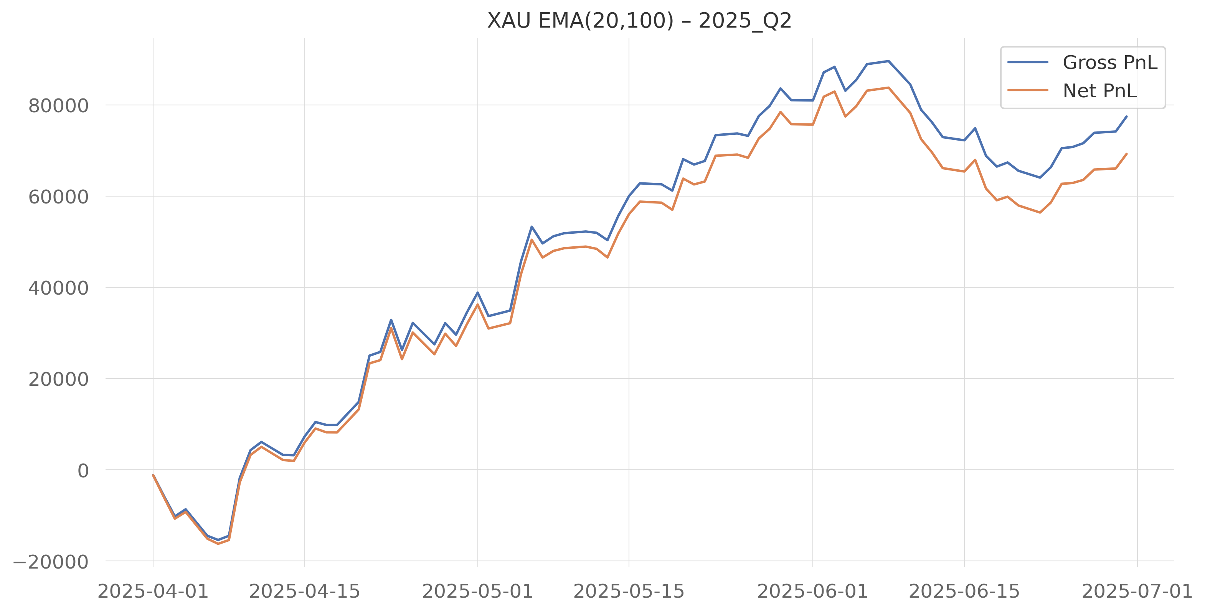 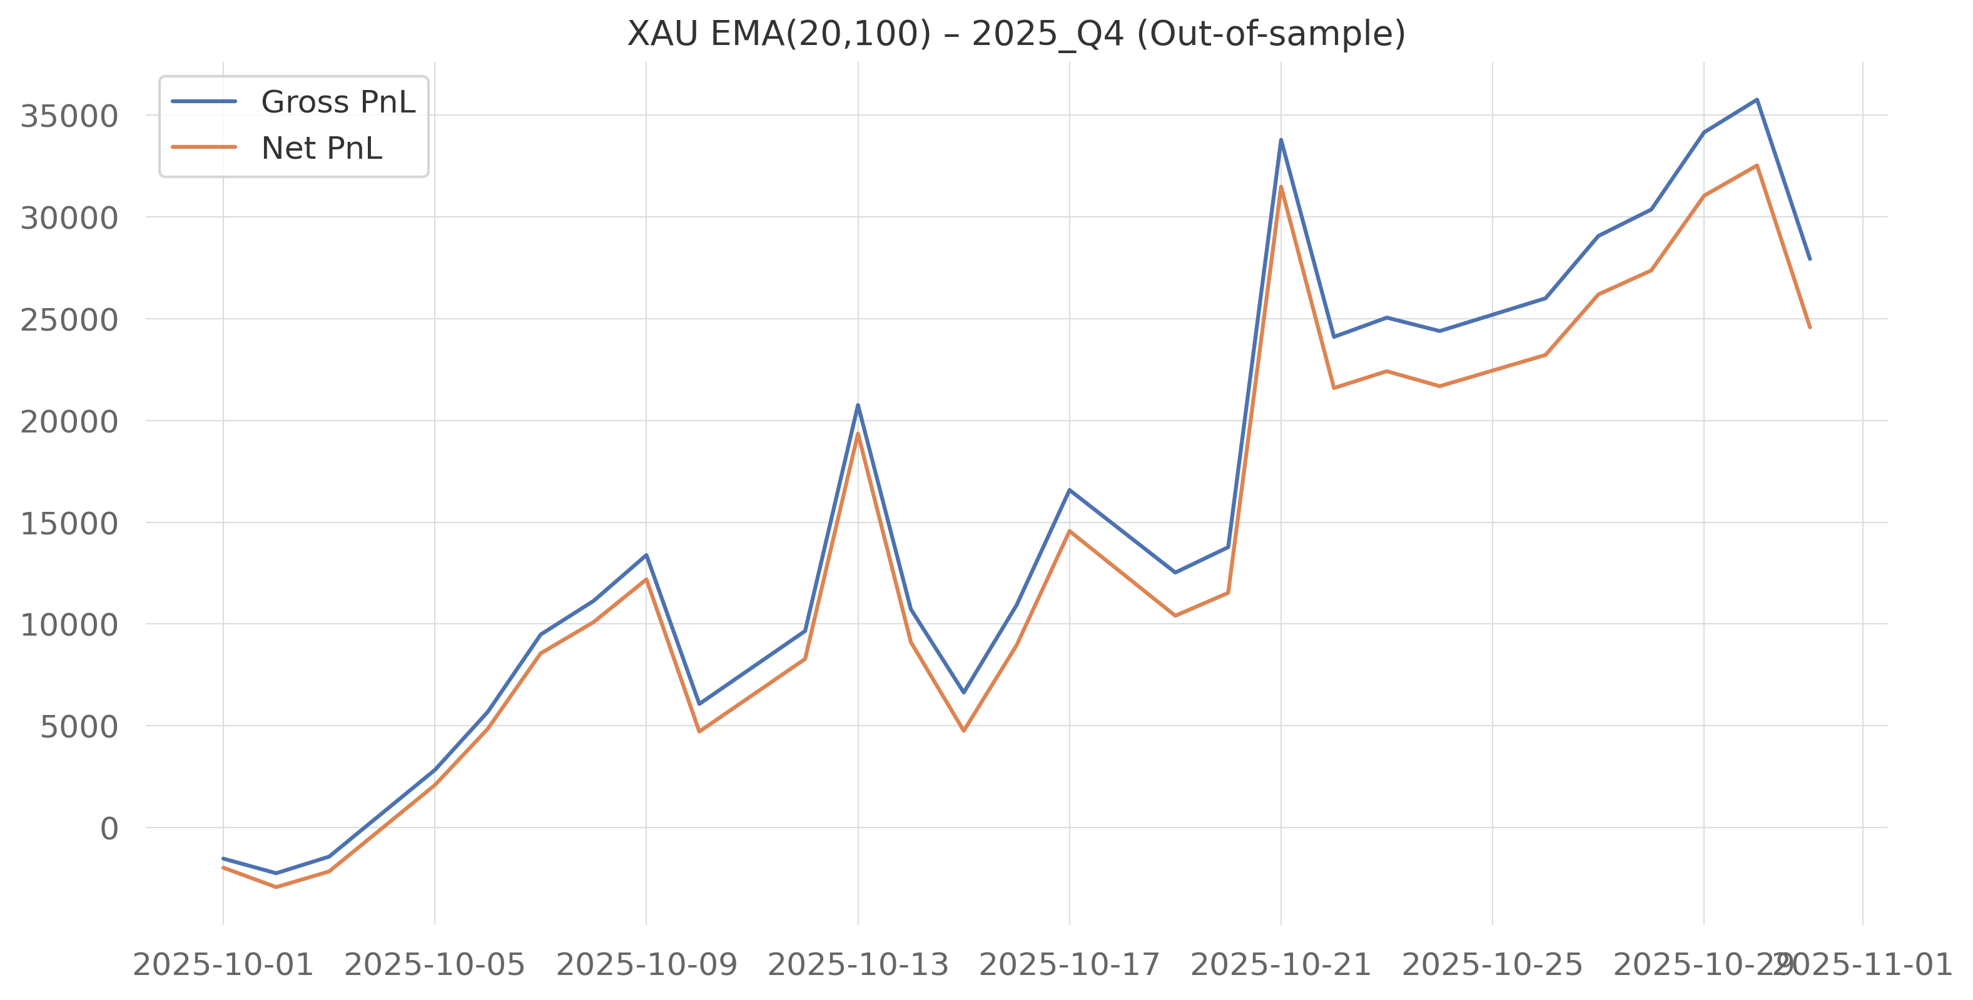

### Adverse and Noisy Regimes

In contrast, quarters such as 2023 Q2, 2024 Q1, 2024 Q3, and 2025 Q3 are characterized by weak or negative net performance. The corresponding equity curves reveal frequent signal reversals, rapid erosion of accumulated gains, and amplified losses after transaction costs.

These periods coincide with reduced trend persistence and increased intraday noise, conditions under which simple EMA crossover strategies are known to struggle.

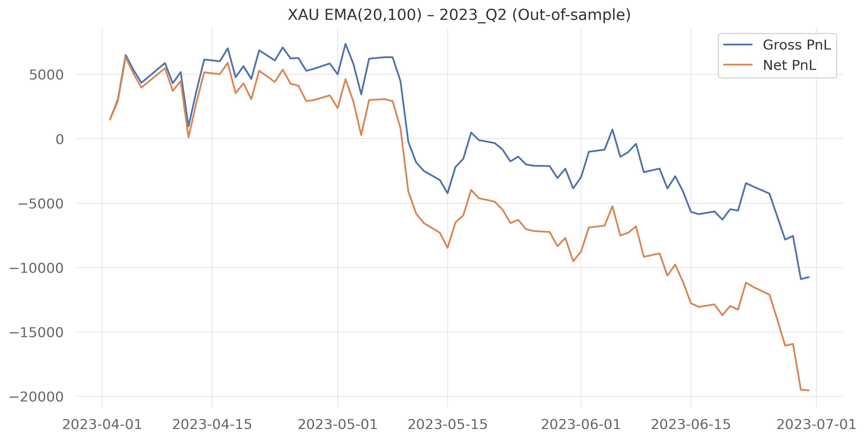 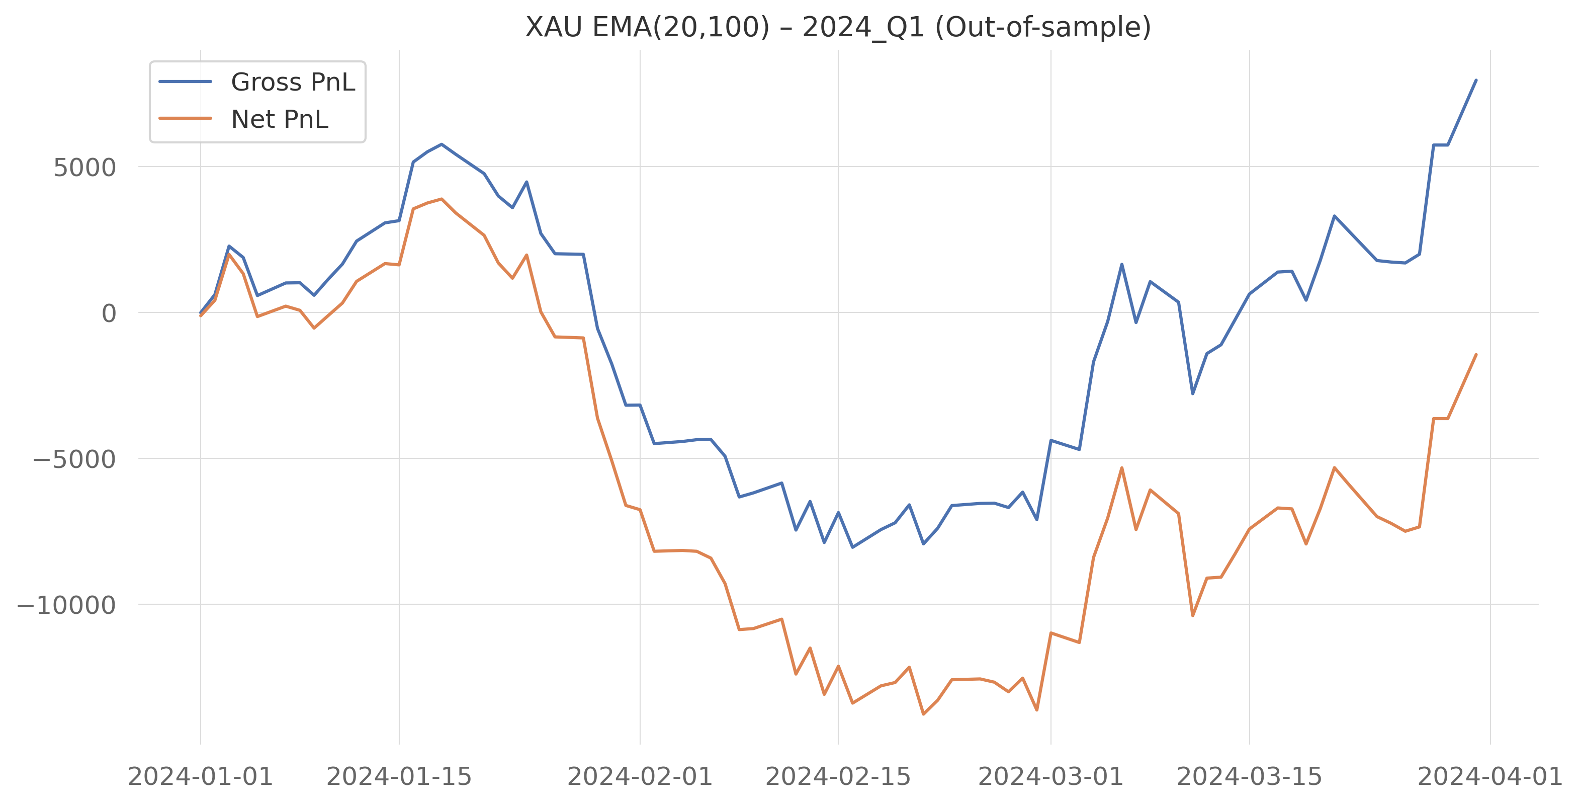

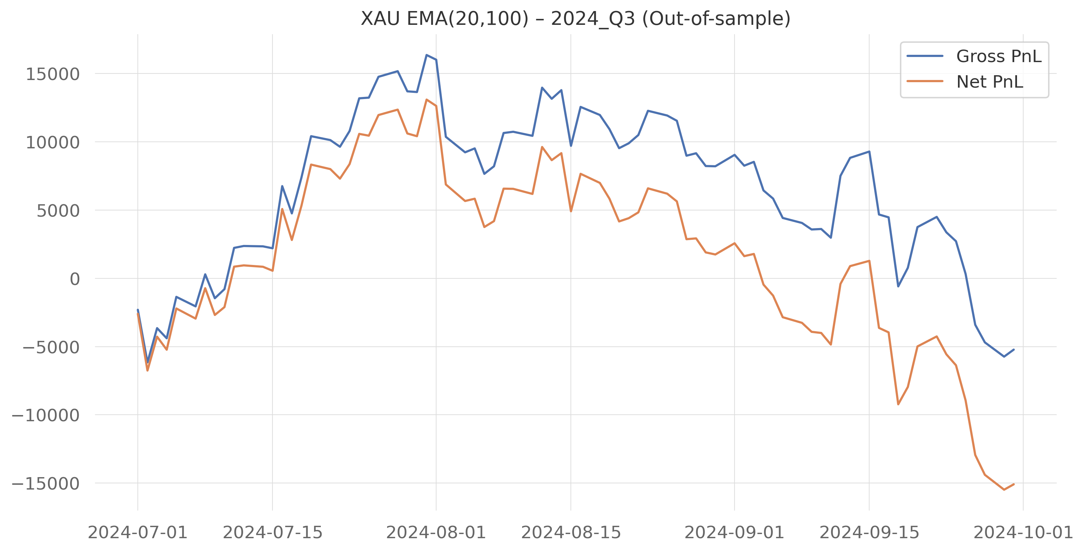 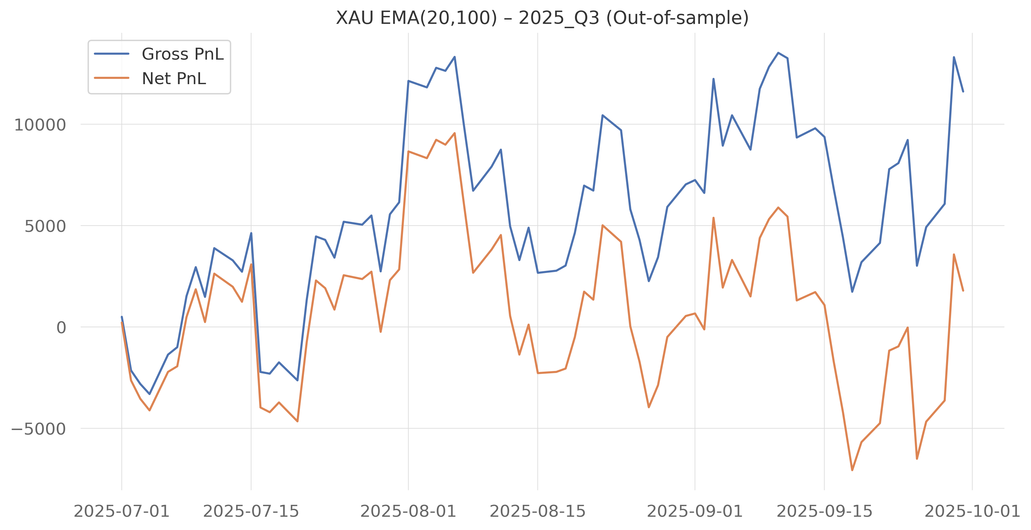

## Discussion

### Overall Findings

#### Group 1 – S&P 500 Futures

* The Group 1 strategy performs well during periods of strong and stable market trends.
* Volatility-based filters help reduce unnecessary trades and limit the impact of transaction costs.
* This makes the strategy more stable compared to a simple EMA crossover.
* When market regimes change, performance deteriorates and drawdowns become more pronounced.
* This shows that even well-designed trend strategies depend heavily on market conditions.

#### Group 2 – Gold (XAU) Futures

* The EMA(20,100) momentum strategy successfully captures large directional price movements in gold.
* In-sample results confirm that gold futures can exhibit tradable trends.
* Out-of-sample performance is weaker due to choppy price behavior and frequent signal reversals.
* High trading frequency causes transaction costs to substantially reduce net profits.
* The strategy performs best during macro-driven trending periods and poorly in range-bound markets.

### Comparison Between Group 1 and Group 2

* Group 1 benefits from volatility filtering, which improves robustness and reduces overtrading.
* Group 2 uses a simpler structure and is therefore more sensitive to market noise and costs.
* Equity index futures show more consistent trend behavior than gold futures.
* In both cases, gross profitability alone is not sufficient for evaluating strategy performance.

## Conclusion

* Trend-following strategies are highly regime-dependent.
* Transaction costs must always be included in performance evaluation.
* Simple strategies are useful for understanding markets, but require additional filters to be viable in practice.
* Out-of-sample testing is essential to assess real-world performance.